Table of Contents

**1.**

|  |  |  |  |  |
| --- | --- | --- | --- | --- |
| Functionality Name | Class Name | Pass /Fail | Defects | Tester |
| **authenticate: Healthcare** App | HealthcareApp | pass | 0 | Bharadwaj |
| **View Appointments: HealthcareApp** | HealthcareApp | Pass | 0 | Bharadwaj |
| **Make appointment: HealthcareApp** | HealthcareApp | pass | 0 | Bharadwaj |
| **Search user: Healthcare App** | HealthcareApp | Pass | 0 | Bharadwaj |
| **View Reports: HealthcareApp** | HealthcareApp | pass | 0 | Bharadwaj |
| **Submit Report:** HealthcareApp | HealthcareApp | Pass | 0 | Bharadwaj |

**Unit Test Results1**

Functionalities **Tested**2

Unit TestCases Executed2

**2.Functionality and Paths3**

authenticate: Healthcare App3

View Appointments: HealthcareApp5

Make appointment: HealthcareApp7

Search user: Healthcare App9

View Reports: HealthcareApp14

Submit Report: HealthcareApp19

|  |  |  |  |  |
| --- | --- | --- | --- | --- |
| Functionality Name | Class Name | Pass /Fail | Defects | Tester |
| **authenticate: Healthcare** App | HealthcareApp | pass | 0 | Bharadwaj |
| **View Appointments: HealthcareApp** | HealthcareApp | Pass | 0 | Bharadwaj |
| **Make appointment: HealthcareApp** | HealthcareApp | pass | 0 | Bharadwaj |
| **Search user: Healthcare App** | HealthcareApp | Pass | 0 | Bharadwaj |
| **View Reports: HealthcareApp** | HealthcareApp | pass | 0 | Bharadwaj |
| **Submit Report:** HealthcareApp | HealthcareApp | Pass | 0 | Bharadwaj |

1. **Unit Test Results**

* 1. **Functionalities Tested**

* 1. **Unit TestCases Executed**

|  |  |  |  |  |
| --- | --- | --- | --- | --- |
| Unit Test Case ID | Unit test case name | Pass | Defect count | Tested By |
| 1 | testAuthenticate | Pass | 0 | Bharadwaj |
| 2 | testAuthenticateFalse | Pass | 0 | Bharadwaj |
| 3 | testViewAppointments | Pass | 0 | Bharadwaj |
| 4 | testViewAppointmentsFalse | Pass | 0 | Bharadwaj |
| 5 | testMakeAppointments | Pass | 0 | Bharadwaj |
| 6 | testMakeAppointmentsFalse | Pass | 0 | Bharadwaj |
| 7 | testSearchuser | Pass | 0 | Bharadwaj |
| 8 | testSearchuserFalse | Pass | 0 | Bharadwaj |
| 9 | testViewReport | Pass | 0 | Bharadwaj |
| 10 | testViewReportFalse | Pass | 0 | Bharadwaj |
| 11 | testSubmitReport | Pass | 0 | Bharadwaj |
| 12 | testSubmitReportFalse | Pass | 0 | Bharadwaj |
| 13 | testisPatient | Pass | 0 | Bharadwaj |
| 14 | testisDoctor | Pass | 0 | Bharadwaj |
| 15 | testGetType | Pass | 0 | Bharadwaj |
| 16 | testGetPassHash | Pass | 0 | Bharadwaj |
| 17 | testGetUsername | Pass | 0 | Bharadwaj |
| 18 | testGetLastLogin | Pass | 0 | Bharadwaj |

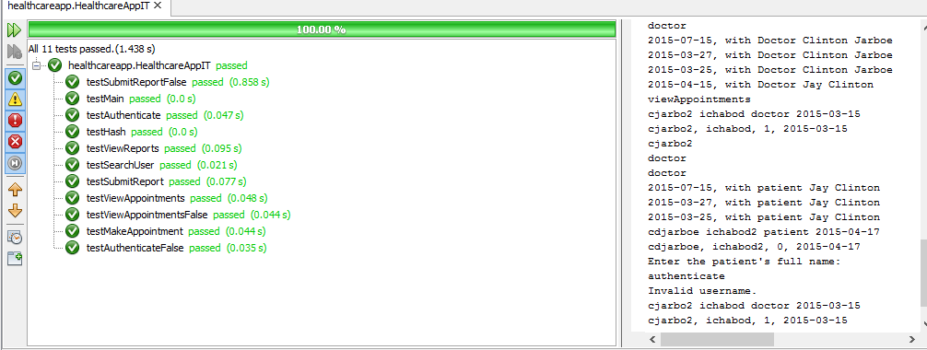

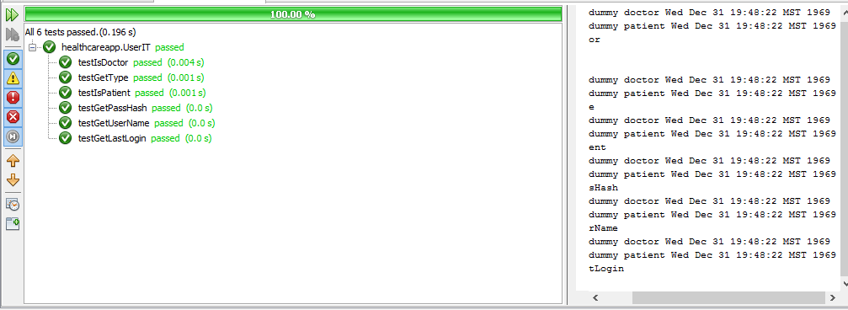

1. **Functionality and Paths**
2. authenticate: Healthcare App

Precondition: User has been registered and has application available.

Post-condition: User is logged into Application

Behavior: The method takes user username and password as input and compares with database to check if it correct and authenticate it.

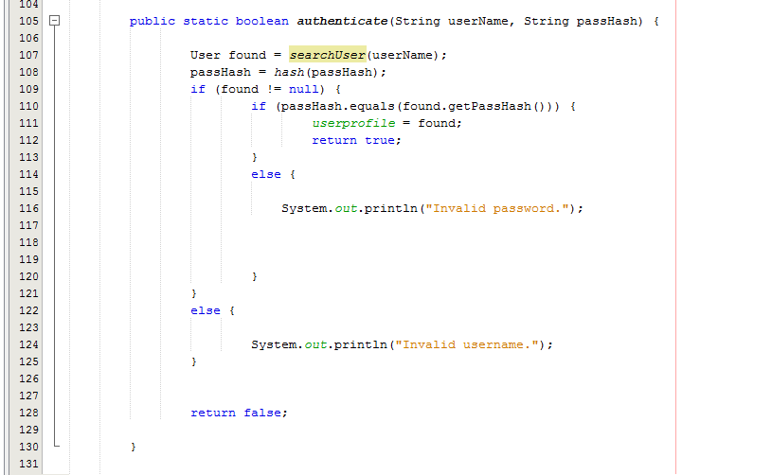

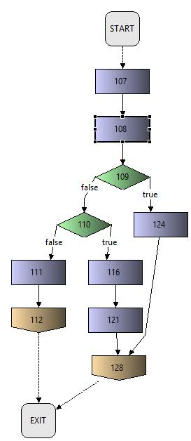

NOTE: the numbers in blocks of the graph are line numbers on the code and haven’t been changed.

Number of independent paths: 2+1 =3

PATHS:

Path 1: 107-108-109-124-128 Test Case (username is incorrect)

Path 2: 107-108-109-110-111-112 Test Case (Username and password is incorrect)

Path 3: 107-108-109-110-116-121-128 Test Case (Password is incorrect)

1. **View Appointments: HealthcareApp**

Precondition: Login is successful. Has at least one appointment

Post condition: Able to appointments.

Behavior: After a user is logged in based on the user shows the appropriate appointments, time, date, doctor, patient and other details. A patient can see his appointments with Doctor in descending order.

A Doctor can see his appointment with patients.

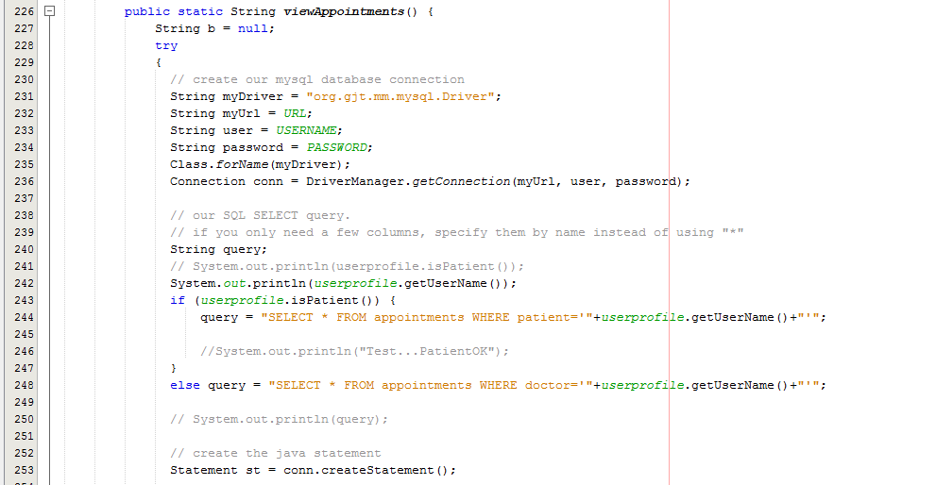

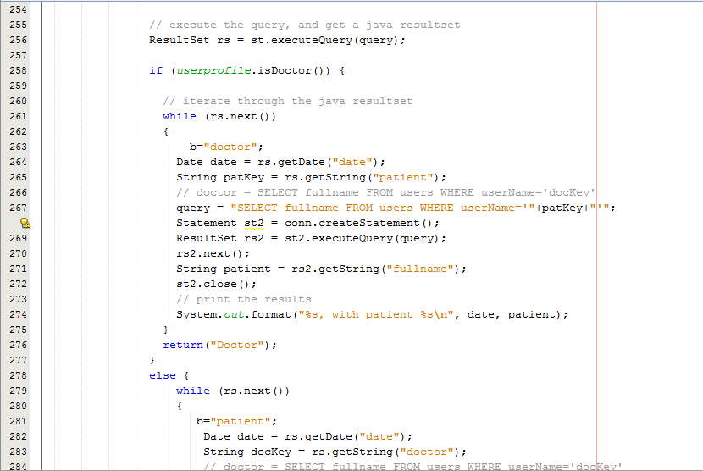

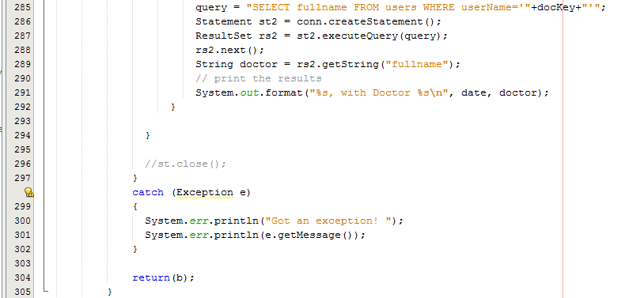

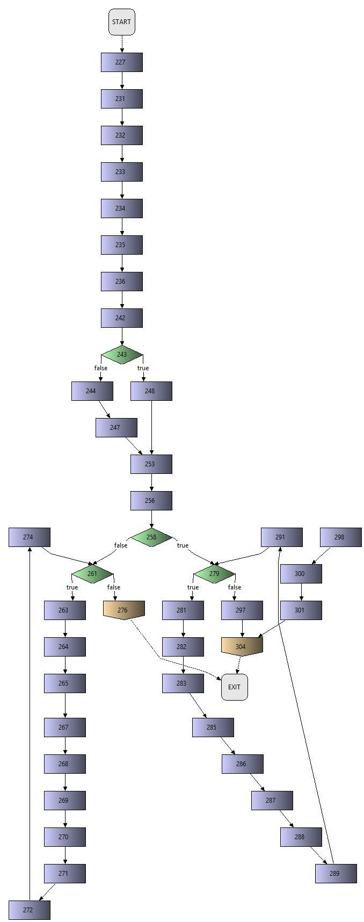

Path 1: 227-231-232-233-234-235-236-242-243-248-253-256-258-279-297-304 Test case (patient)

Path 2: 227-231-232-233-234-235-236-242-243-248-253-256-258-279-281-282-283-285-286-287-288-289-291-279-297-304 Test Case Doctor

Path 3: 227-231-232-233-234-235-236-242-243-248-253-256-258-261-276 Test Case Doctor

Path 4: 227-231-232-233-234-235-236-242-243-248-253-256-258-261-276

Path 5: 227-231-232-233-234-235-236-242-243-248-253-256-258-261-263-264-265-267-268-269-270 -271-274-261-276 Test Case Doctor

1. **Make appointment: HealthcareApp**

Pre-Condition: User is able to login and has permission to make appointment.

Post-condition: Able to select a doctor and make appointment.

Behavior: Make Appointment helps to schedule appointment for a patient by healthcare professional

User Enters Patient Id, Doctor, time, date and Appointment is set at the given time.

Only authorized Personal can set Appointment.

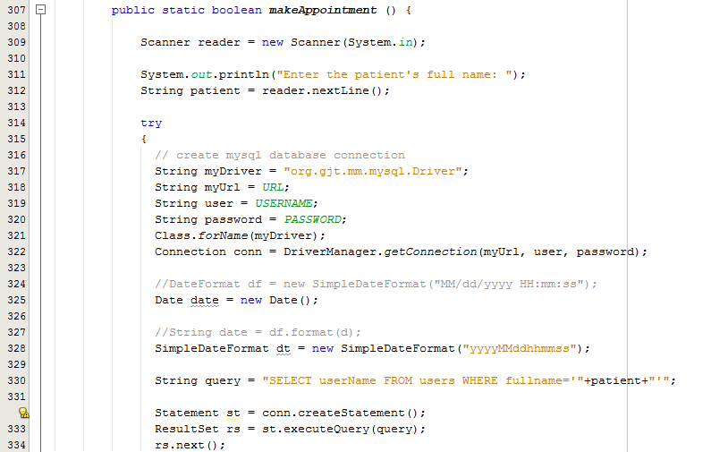

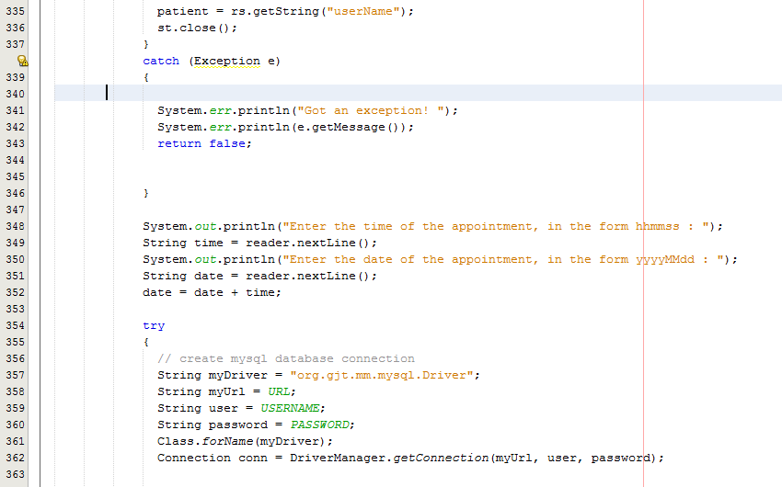

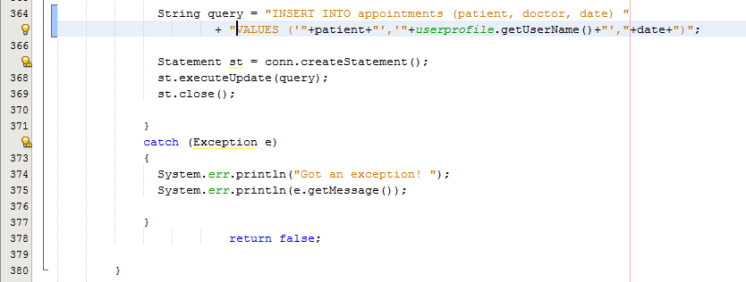

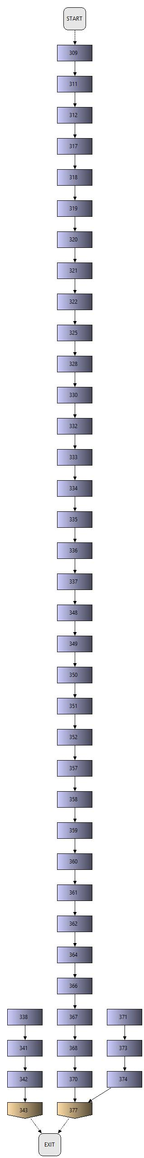

Path 1: 309-310-311-312-317-319-320-322-325-328-330-332-333-334-335-336-337-348-349-350-351-357-358-359-360-361-362-364-366-367-368-370-372

1. **Search user: Healthcare App**

**Precondition:** User is Log in to the System.

Post Condition: None.

Behavior: Searches in the database if the User is available or not.

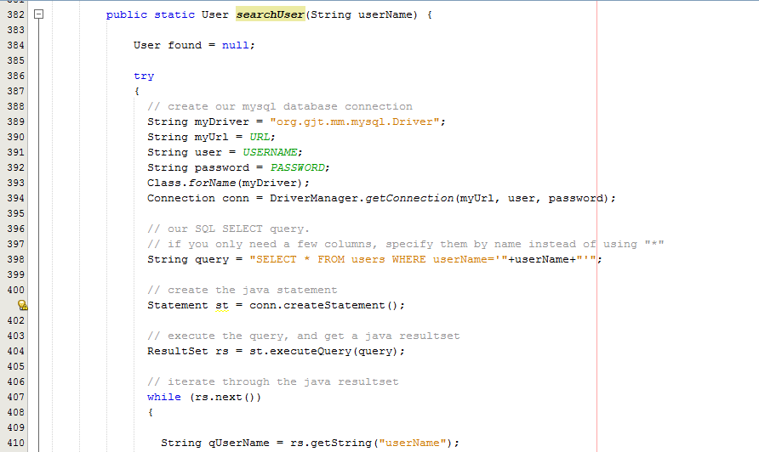

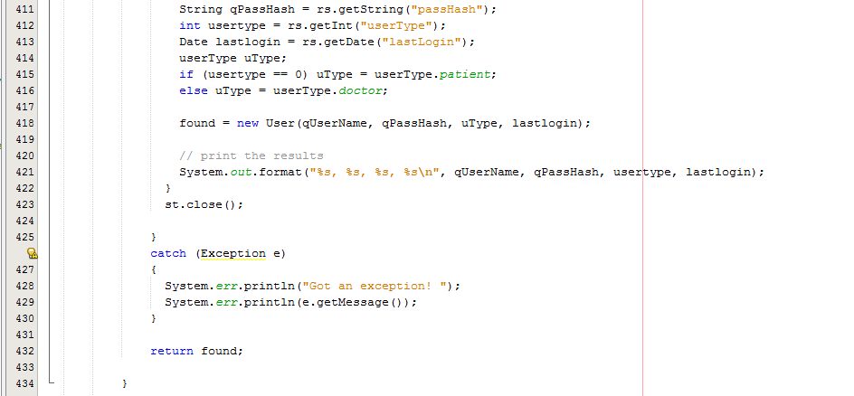

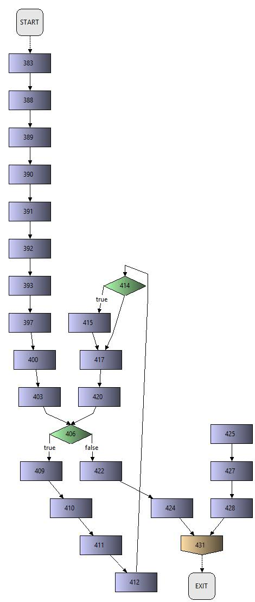

Paths: 2+1=3

Path 1:383-388-389-390-391-392-393-397-400-403-406-424-431

Path 2: 383-388-389-390-391-392-393-397-400-403-406-409-410-411-412-414-415-417-420-406-422-424-431

Path 3: 383-388-389-390-391-392-393-397-400-403-406-409-410-411-412-414-415-417-420-406-422-424-431

1. **View Reports: HealthcareApp**

**Pre-Condition:**  User is logged in and has reports created.

Post-Condition: None

Behavior: User after log in on home page is able to see a view reports button. Selecting a report on the reports displayed and clicking view report button shows reports.

Reports contain doctor name, symptoms of patient and comments.

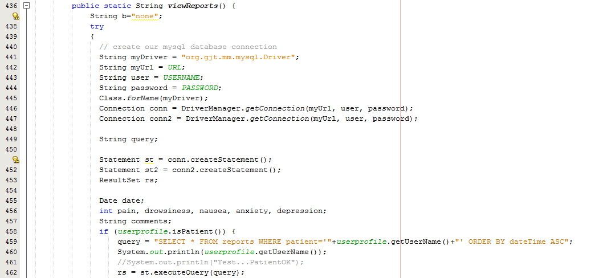

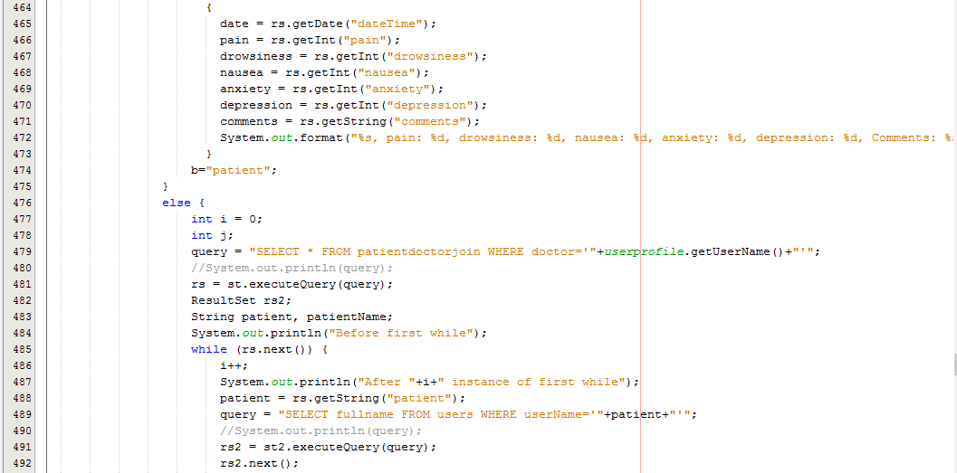

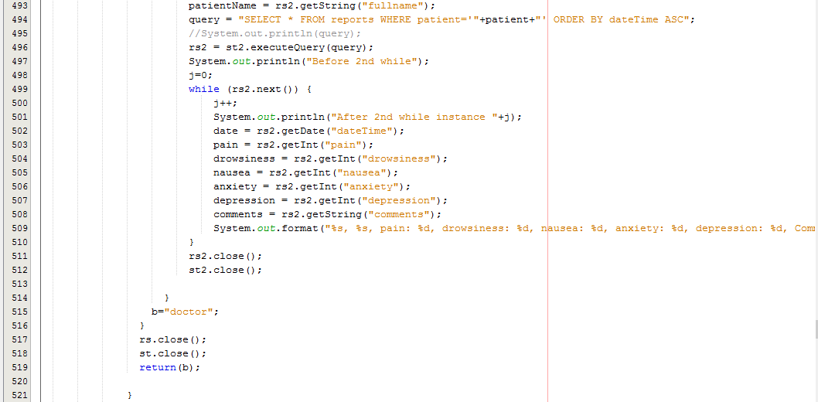

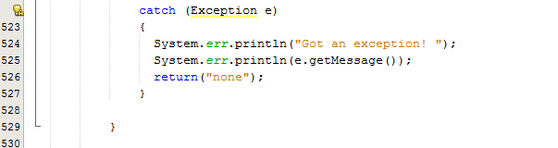

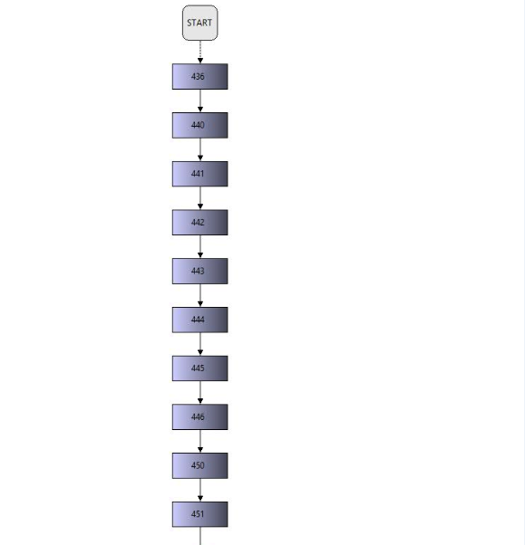

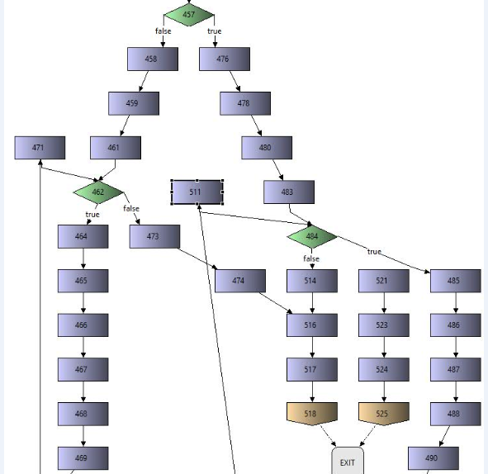

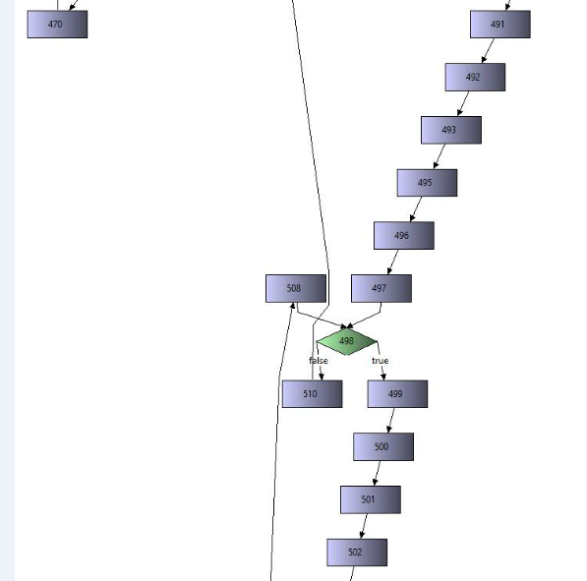

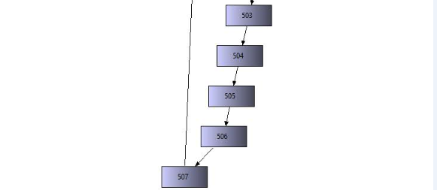

Paths 4+1=5

**Path1**:436+440+441+442+443+444+445+446+450+451+457true+476+478+480+483+484true+485+486+487+488+490+491+492+493+495+496+497+498true+499+500+504+507+508+510+511+484false+514+516+517+518

**Path2**:436+440+441+442+443+444+445+446+450+451+457true+476+478+480+483+484false+514+516+517+518

**Path3**:436+440+441+442+443+444+445+446+450+451+457false+458+459+461+462true+464+466+469+471+462false+473+474+516+517+518

**Path4**:436+440+441+442+443+444+445+446+450+451+457false 473+474+516+517+518

**Path5**:436+440+441+442+443+444+445+446+450+451+457+476+478+480+483+484true+485+486+487+488+490+491+492+493+495+496+497+498false+510+511+484false+514+516+517+518

1. **Submit Report: HealthcareApp**

**Precondition:**  User is logged in and has authorization to submit report.

**Post-condition:** None

Behavior:

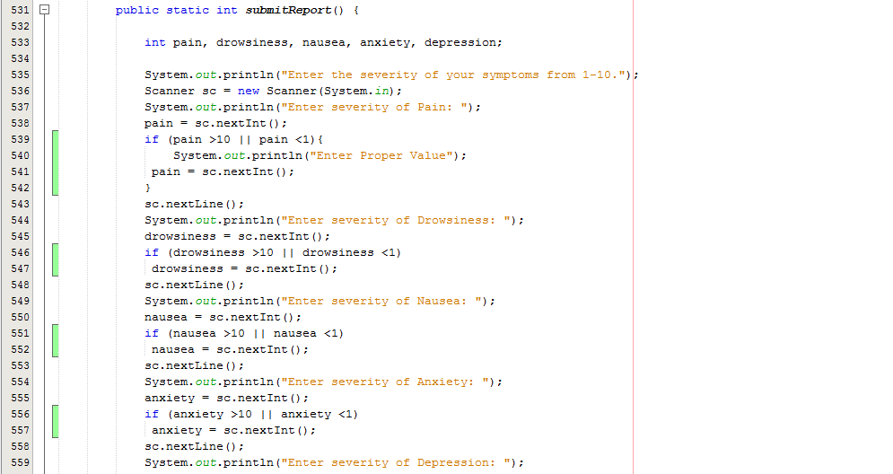

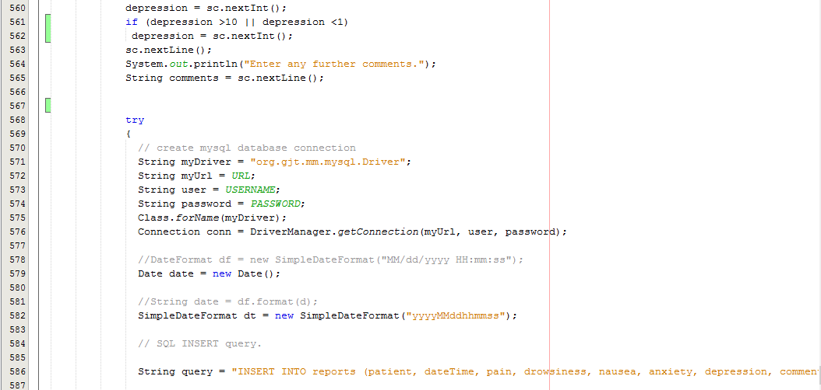

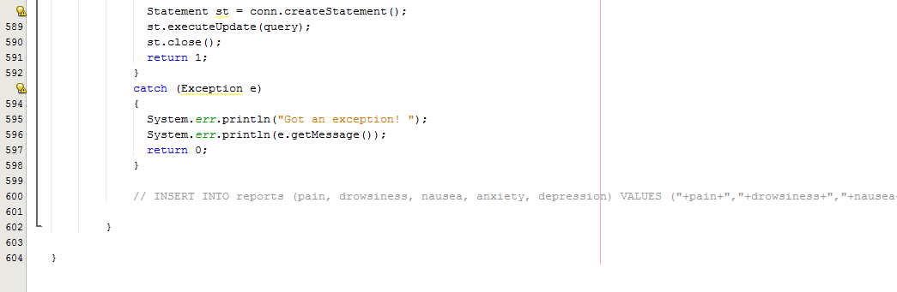

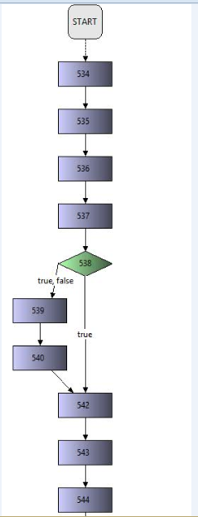

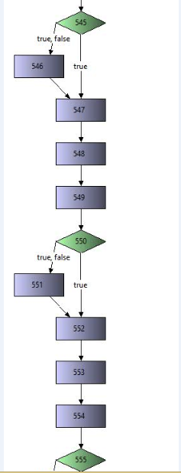

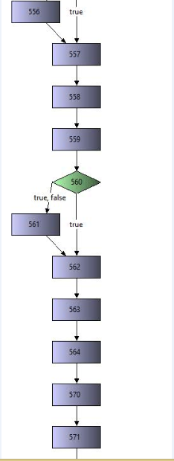

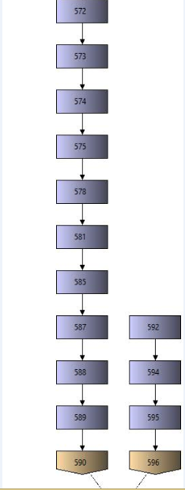

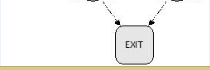

Paths: 5+1=6

Path 1:534-535-536-537-538-542-543-544-545-true-547-548-549-550-true-552-553-554-555-557-558-559-560-562-564-570-571-572-573-574-575-578-581-585-587-588-589-590

Path 2:534-535-536-537-538-539-540-542-543-544-545-true-547-548-549-550-true-552-553-554-555-557-558-559-560-562-564-570-571-572-573-574-575-578-581-585-587-588-589-590

Path 3: 534-535-536-537-538-539-540-542-543-544-545-false-546-547-548-549-550-true-552-553-554-555-557-558-559-560-562-564-570-571-572-573-574-575-578-581-585-587-588-589-590